**File Processing: Design a base class File with a virtual function readData() that has an empty body. Create derived classes like TextFile and ImageFile inheriting from File and overriding readData() with their specific reading procedures. Implement a function that takes a pointer to File as input, attempts to read the data using the readData() function, and handles potential errors based on the actual derived class type (e.g., different file formats).**

#include <iostream>

#include <string>

using namespace std;

// Base class File

class File {

public:

virtual void readData() = 0; // Pure virtual function

virtual ~File() {}

};

// Derived class TextFile

class TextFile : public File {

public:

void readData() override {

cout << "Reading data from text file." << endl;

if (/* condition indicating error */ false) {

handleError();

} else {

cout << "Text file read successfully." << endl;

}

}

void handleError() {

cout << "Error: Could not read text file." << endl;

}

};

// Derived class ImageFile

class ImageFile : public File {

public:

void readData() override {

cout << "Reading data from image file." << endl;

if (/* condition indicating error */ false) {

handleError();

} else {

cout << "Image file read successfully." << endl;

}

}

void handleError() {

cout << "Error: Could not read image file." << endl;

}

};

// Abstract factory class FileFactory

class FileFactory {

public:

virtual File* createFile() = 0; // Pure virtual function

virtual ~FileFactory() {}

};

class TextFileFactory : public FileFactory {

public:

File* createFile() override {

return new TextFile();

}

};

class ImageFileFactory : public FileFactory {

public:

File* createFile() override {

return new ImageFile();

}

};

void readFile(FileFactory* factory) {

File* file = factory->createFile();

file->readData();

delete file;

}

int main() {

FileFactory* factory = nullptr;

string choice;

cout << "Enter file type (text/image): ";

cin >> choice;

if (choice == "text") {

factory = new TextFileFactory();

} else if (choice == "image") {

factory = new ImageFileFactory();

} else {

cout << "Invalid choice." << endl;

return 1;

}

readFile(factory);

delete factory;

return 0;

}

**Output:**

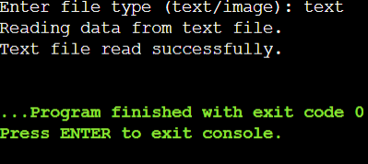

**Design an abstract factory class hierarchy to create different families of products (e.g., furniture). Use pointers and runtime polymorphism. Define an abstract base class FurnitureFactory with a virtual function createChair(). Create derived classes like ModernFurnitureFactory and ClassicFurnitureFactory that override createChair() to return pointers to concrete chair objects specific to their style. Utilize the factory pattern with runtime polymorphism to allow for flexible furniture creation based on user choice**

#include <iostream>

using namespace std;

class Chair {

public:

virtual void useChair() = 0; // Pure virtual function

virtual ~Chair() {}

};

class ModernChair : public Chair {

public:

void useChair() override {

cout << "Using a modern chair." << endl;

}

};

class ClassicChair : public Chair {

public:

void useChair() override {

cout << "Using a classic chair." << endl;

}

};

class FurnitureFactory {

public:

virtual Chair* createChair() = 0; // Pure virtual function

virtual ~FurnitureFactory() {}

};

class ModernFurnitureFactory : public FurnitureFactory {

public:

Chair* createChair() override {

return new ModernChair();

}

};

class ClassicFurnitureFactory : public FurnitureFactory {

public:

Chair* createChair() override {

return new ClassicChair();

}

};

void createFurniture(FurnitureFactory* factory) {

Chair* chair = factory->createChair();

chair->useChair();

delete chair; // Clean up

}

int main() {

FurnitureFactory* factory = nullptr;

string choice;

cout << "Enter furniture style (modern/classic): ";

cin >> choice;

if (choice == "modern") {

factory = new ModernFurnitureFactory();

} else if (choice == "classic") {

factory = new ClassicFurnitureFactory();

} else {

cout << "Invalid choice." << endl;

return 1;

}

createFurniture(factory);

delete factory; // Clean up

return 0;

}

**Output:**

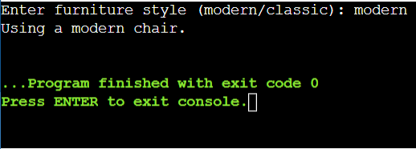

**Data Structures:**

**Create a C++ structure named Flight to represent flight information, including:**

**Flight number (string)**

**Departure and arrival airports (strings)**

**Departure and arrival date/time (strings or appropriate data types)**

**Number of available seats (integer)**

**Price per seat (float)**

**Consider creating another structure named Passenger (optional) to store passenger details if needed (name, passport information etc.).**

#include <iostream>

#include <string>

using namespace std;

// Structure to represent flight information

struct Flight {

string flightNumber;

string departureAirport;

string arrivalAirport;

string departureDateTime;

string arrivalDateTime;

int availableSeats;

float pricePerSeat;

};

struct Passenger {

string name;

string passportNumber;

};

int main() {

Flight f1;

f1.flightNumber = "BA1476";

f1.departureAirport = "Hyderabad";

f1.arrivalAirport = "Delhi";

f1.departureDateTime = "2024-07-06 1:00";

f1.arrivalDateTime = "2024-07-06 18:00";

f1.availableSeats = 150;

f1.pricePerSeat = 3000.0;

// Displaying flight information

cout << "Flight Number: " << f1.flightNumber << endl;

cout << "Departure Airport: " << f1.departureAirport << endl;

cout << "Arrival Airport: " << f1.arrivalAirport << endl;

cout << "Departure Date/Time: " << f1.departureDateTime << endl;

cout << "Arrival Date/Time: " << f1.arrivalDateTime << endl;

cout << "Available Seats: " << f1.availableSeats << endl;

cout << "Price per Seat: " << f1.pricePerSeat << endl;

return 0;

}

**Output:**

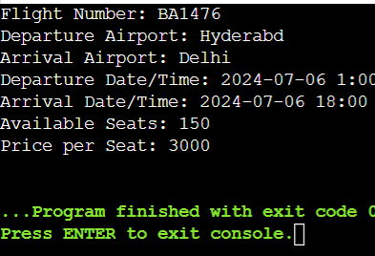

**Functions:**

**Develop C++ functions to:**

**Display a list of available flights based on user-specified origin and destination airports (consider searching by date range as well).**

**Book a specific number of seats for a chosen flight (handle cases where insufficient seats are available).**

**Cancel a booking for a specific flight and number of seats (ensure the user cancels the correct booking).**

**Display a list of all booked flights for a specific user (if using Passenger structure).**

**Implement error handling for invalid user input (e.g., trying to book negative seats).**

**Include a function to add new flights to the system (consider adding flights dynamically if needed).**

#include <iostream>

#include <vector>

#include <string>

using namespace std;

class Flight {

private:

string flightNumber;

string origin;

string destination;

string date;

int availableSeats;

public:

Flight(string flightNumber, string origin, string destination, string date, int availableSeats)

: flightNumber(flightNumber), origin(origin), destination(destination), date(date), availableSeats(availableSeats) {}

string getFlightNumber() const {

return flightNumber;

}

string getOrigin() const {

return origin;

}

string getDestination() const {

return destination;

}

string getDate() const {

return date;

}

int getAvailableSeats() const {

return availableSeats;

}

void displayFlightDetails() const {

cout << "Flight Number: " << flightNumber << endl;

cout << "Origin: " << origin << endl;

cout << "Destination: " << destination << endl;

cout << "Date: " << date << endl;

cout << "Available Seats: " << availableSeats << endl;

}

void bookSeats(int numSeats) {

if (numSeats > 0 && numSeats <= availableSeats) {

availableSeats -= numSeats;

cout << numSeats << " seats booked successfully for flight " << flightNumber << endl;

} else {

cout << "Error: Insufficient seats available." << endl;

}

}

void cancelBooking(int numSeats) {

if (numSeats > 0 && numSeats <= availableSeats) {

availableSeats += numSeats;

cout << numSeats << " seats cancelled successfully for flight " << flightNumber << endl;

} else {

cout << "Error: Invalid number of seats to cancel." << endl;

}

}

};

class FlightManager {

private:

vector<Flight> flights;

public:

void addFlight(const Flight& flight) {

flights.push_back(flight);

}

void displayAvailableFlights(const string& origin, const string& destination, const string& date) {

for (const auto& flight : flights) {

if (flight.getOrigin() == origin && flight.getDestination() == destination && flight.getDate() == date) {

flight.displayFlightDetails();

cout << endl;

}

}

}

void bookSeats(const string& flightNumber, int numSeats) {

for (auto& flight : flights) {

if (flight.getFlightNumber() == flightNumber) {

flight.bookSeats(numSeats);

return;

}

}

cout << "Flight with number " << flightNumber << " not found." << endl;

}

void cancelBooking(const string& flightNumber, int numSeats) {

for (auto& flight : flights) {

if (flight.getFlightNumber() == flightNumber) {

flight.cancelBooking(numSeats);

return;

}

}

cout << "Flight with number " << flightNumber << " not found." << endl;

}

};

int main() {

FlightManager manager;

manager.addFlight(Flight("Bd123", "Hyderabad", "Bangalore", "2024-07-05", 150));

manager.addFlight(Flight("Fa345", "Bangalore", "pune", "2024-07-06", 200));

cout << "Available Flights from Hyderabad to Bangalore on 2024-07-05:" << endl;

manager.displayAvailableFlights("Hyderabad", "Bangalore", "2024-07-05");

cout << "Enter number of seats to book: ";

int seatsToBook;

cin >> seatsToBook;

manager.bookSeats("Bd123", seatsToBook);

cout << "Enter number of seats to cancel: ";

int seatsToCancel;

cin >> seatsToCancel;

manager.cancelBooking("Bd123", seatsToCancel);

return 0;

}

**Output:**

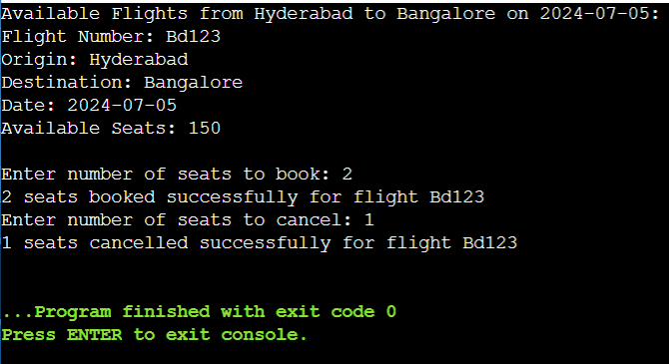

**Lambda Expression Example:**

#include <iostream>

using namespace std;

int multiply(int a, int b);

int main()

{

cout<<multiply(4,5)<<endl;

cout<<[](int a, int b){return a*b;}(4,5)<<endl;

auto f=[](int a, int b){return a*b;};

cout<<f(4,5)<<endl;

}

int multiply(int a, int b){

return a*b;

}

**Output:**

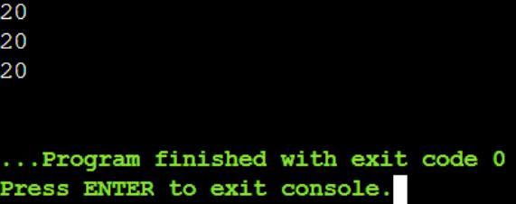

**Capture By Value:**

#include <iostream>

using namespace std;

void lambda_value_capture(){

int value = 1;

auto copy_value = [value]{

return value;

};

value=100;

auto stored_value = copy_value();

cout<<"stored_value = "<<stored_value<<endl;

}

int main(){

lambda_value_capture();

return 0;

}

**Output:**

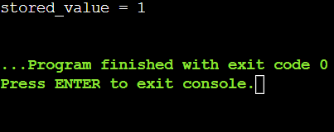

**Reference capture:**

#include <iostream>

using namespace std;

void lambda_reference_capture(){

int value = 1;

auto copy_value = [&value]{

return value;

};

value=100;

auto stored_value = copy_value();

cout<<"stored_value = "<<stored_value<<endl;

}

int main(){

lambda_reference_capture();

return 0;

}

**Output:**

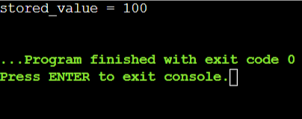

**Capture By Both(Value & Reference)**

#include<iostream>

using namespace std;

int main()

{

int m = 0;

int n = 0;

[&,n](int a) mutable{ m = ++n +a;}(4);

cout<<m<<endl<<n<<endl;

}

**Output:**

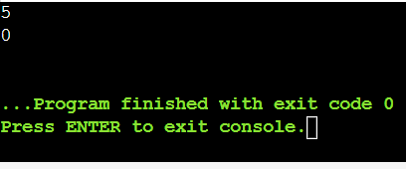

**Use Case:**

#include<iostream>

#include<algorithm>

#include<vector>

using namespace std;

void assign(int& v)

{

static int n = 1; v = n++;

}

void print(int v)

{

cout<<v<<" ";

}

int main()

{

vector<int>vec(10);

for_each(vec.begin(),vec.end(), print);

cout<<endl;

for_each(vec.begin(),vec.end(), assign);

for_each(vec.begin(),vec.end(), print);

return 0;

}

**Output:**

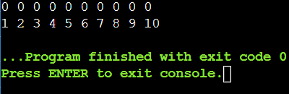

**Practice Problem Statement:**

**Scenario: You're working on a data analysis project where you need to filter a list of integers based on whether they are even or odd. You want to use a lambda expression to achieve this filtering.**

**Task:**

**1.Define a function named filter_even_odds that takes two arguments:**

**const std::vector<int>& numbers: The vector containing the integer values.**

**bool is_even: A flag indicating whether to filter even (true) or odd (false) numbers.**

**Inside the function, use a lambda expression to iterate through the numbers vector.**

**Within the lambda, check if the current number is even using the modulo operator (%).**

**If the even/odd condition matches the is_even flag, add the number to a new filtered vector.**

**Return the filtered vector from the filter_even_odds function.**

#include <iostream>

#include <vector>

using namespace std;

vector<int> filter_even_odds(const vector<int>& numbers, bool is_even) {

vector<int> filtered;

for (int num : numbers) {

if (is_even == (num % 2 == 0)) {

filtered.push_back(num);

}

}

return filtered;

}

int main() {

vector<int> numbers = {1, 2, 3, 4, 5, 6, 7, 8, 9, 10, 11, 12, 13, 14, 15};

// Filter even numbers

vector<int> evens = filter_even_odds(numbers, true);

cout << "Even numbers: ";

for (int num : evens) {

cout << num << " ";

}

cout << endl;

// Filter odd numbers

vector<int> odds = filter_even_odds(numbers, false);

cout << "Odd numbers: ";

for (int num : odds) {

cout << num << " ";

}

cout << endl;

return 0;

}

**Output:**

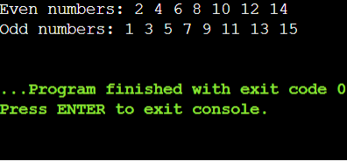

**2. Finding Maximum Value:**

**Scenario: You have a list of objects and want to find the object with the highest value based on a specific criterion.**

**Task:**

**Define a function named find_max that takes two arguments:**

**const std::vector<T>& objects: The vector containing the objects (can be any type T).**

**std::function<bool(const T& a, const T& b)> compare: A function object (e.g., a lambda) that defines the comparison logic for finding the maximum.**

**Inside the function, use a std::accumulate with a lambda expression to iterate through the objects vector.**

**Within the inner lambda, compare the current element with the current maximum using the provided compare function.**

**If the current element is greater (based on the comparison logic), return it as the new maximum.**

#include <iostream>

#include <vector>

#include <functional>

#include <algorithm>

using namespace std;

template <typename T, typename Compare>

T find_max(const vector<T>& objects, Compare compare) {

return *std::max_element(objects.begin(), objects.end(), compare);

}

struct Object {

int value;

string name;

};

int main() {

vector<Object> objects = {{100, "Object1"}, {50, "Object2"}, {70, "Object3"}, {60, "Object4"}};

auto compare = [](const Object& a, const Object& b) { return a.value < b.value; };

Object max_obj = find_max(objects, compare);

cout << "The object with the highest value is: " << max_obj.name << " with value " << max_obj.value << endl;

return 0;

}

**Output:**

